**CE Talent Competition Online Process**

To fill out Cultural Exploration Talent Competition, go to CE site <http://www.culturalexploration.org>, hover over the *Scholastic Competition* menu and then select *Registration*.



The following page appears for the user to select competition type:

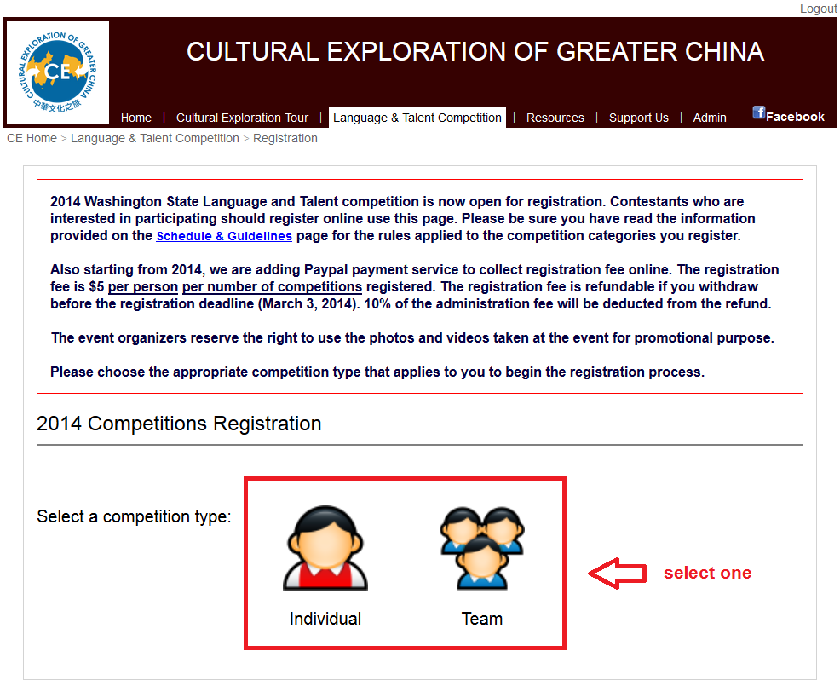

**Individual Competition**

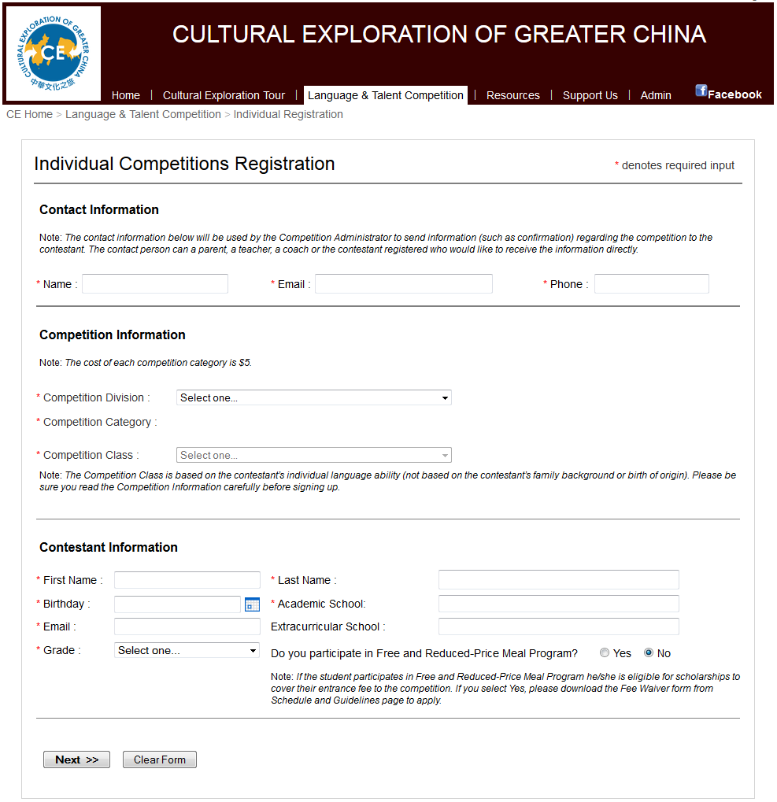

Input notes:

* Input fields with red asterisk are required fields.
* Competition category will appear when a competition division is selected.
* Competition class will be enabled if a competition category requires it.
* Academic and Extracurricular school will show available school list as the user types in text.
* Use **Next** button to move to payment page as shown below.

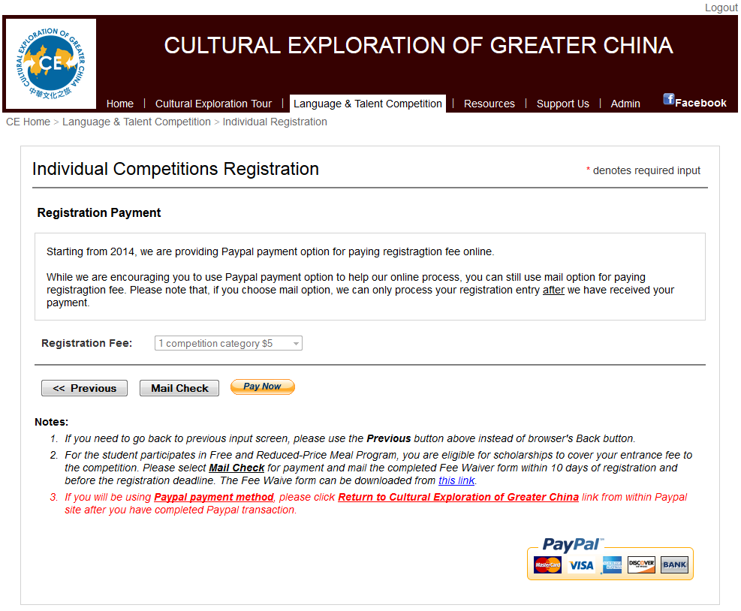

* Click Paypal icon button if the payment is to be paid through Paypal.

CE site will redirect the user to the Paypal payment page. If the user cancels the Paypal payment, the registration will be nullified.

* Click *Mail Check* button if the payment is to be mailed in with check. An acknowledge dialog as show below will appear.

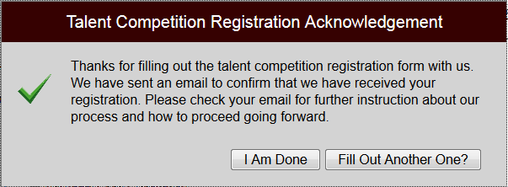

* Once the applicant fills out the form, the data is saved to a file with the following filename: ***contactname_phone_category_class_division_contestantfirst_contestantlast_year.xml***

**Team Competition**

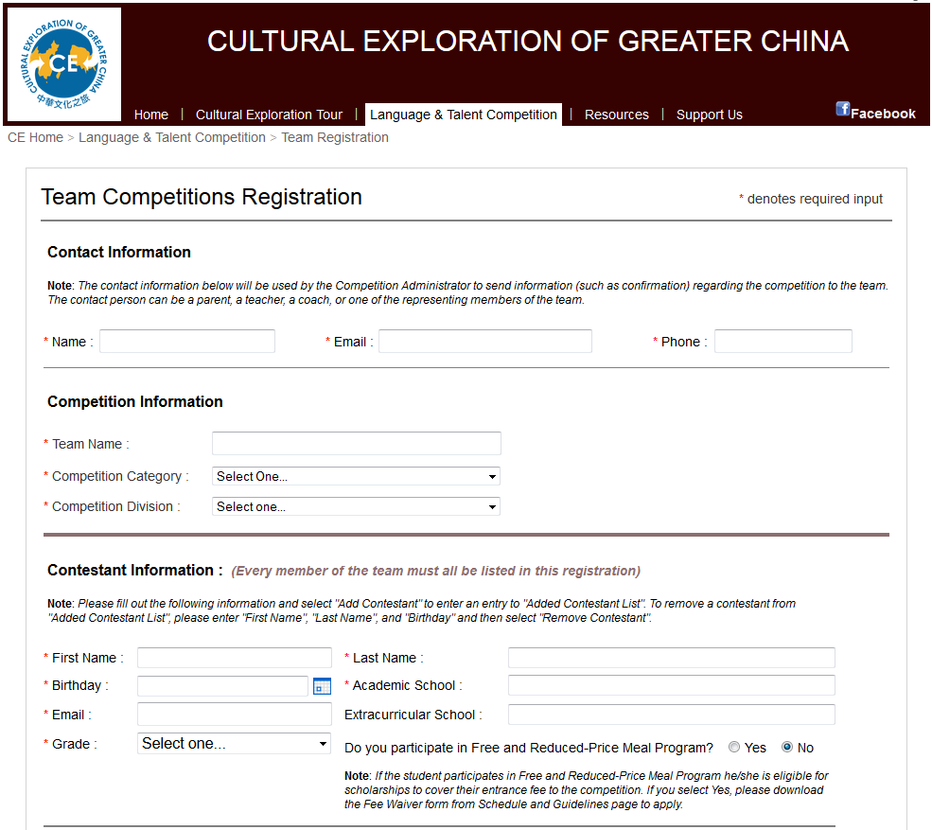

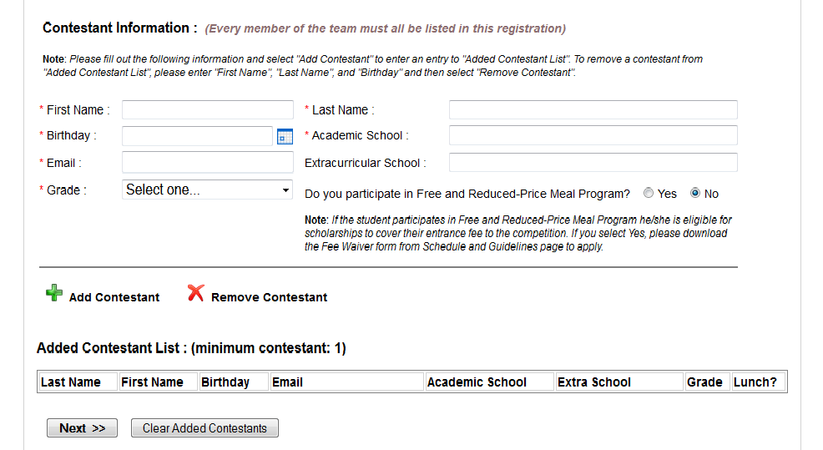

Input notes:

* Input fields with red asterisk are required fields.
* Competition division will be populated when a competition category is selected.
* Academic and Extracurricular school will show available school list as the user types in text.
* Minimum contestant requirement needs to be met for the category/division selected.
* Use ***Add Contestant*** link button to add a contestant to the team. The added contestant will appear in the *Added Contestant List* grid.
* To remove added contestant, enter the contestant first name, last name, and birthday and then click ***Remove Contestant*** link button. If the contestant is found, it will be removed from the *Added Contestant List* grid.
* Use **Next** button to move to payment page as shown below.

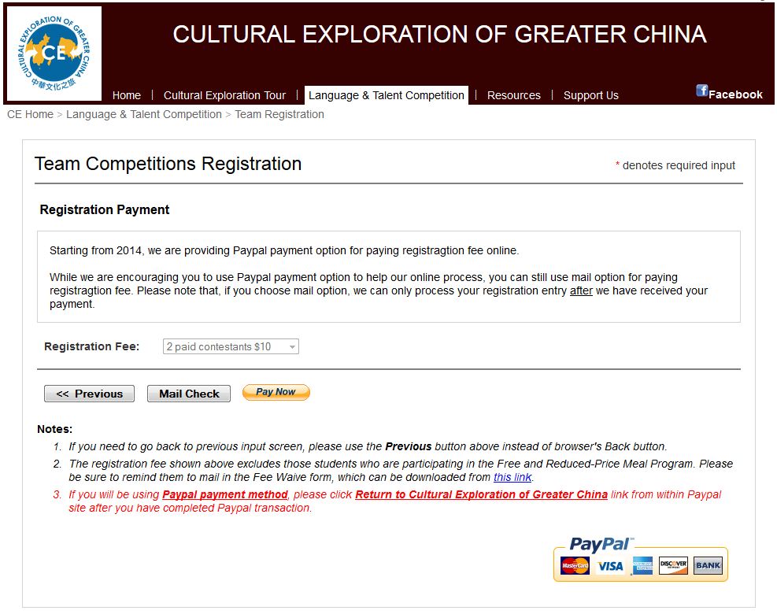

* Click Paypal icon button if the payment is to be paid through Paypal.

CE site will redirect the user to the Paypal payment page. If the user cancels the Paypal payment, the registration will be nullified. If the user returns to CE site from Paypal payment page, an acknowledge dialog will appear to complete the registration.

* Click *Mail Check* button if the payment is to be mailed in with check. An acknowledge dialog will appear to complete the registration.
* Once the applicant fills out the form, the data is saved to a file with the following filename: ***contactname_phone_category_class_division_teamname_year.xml***.

**Online Process for Cultural Exploration Talent Competition Registration**

To Process Cultural Exploration Talent Competition registration, log onto the CE site <http://www.jcubictech.com>. If you save your login information offered by the browser, you don’t need to type in again next time you login.



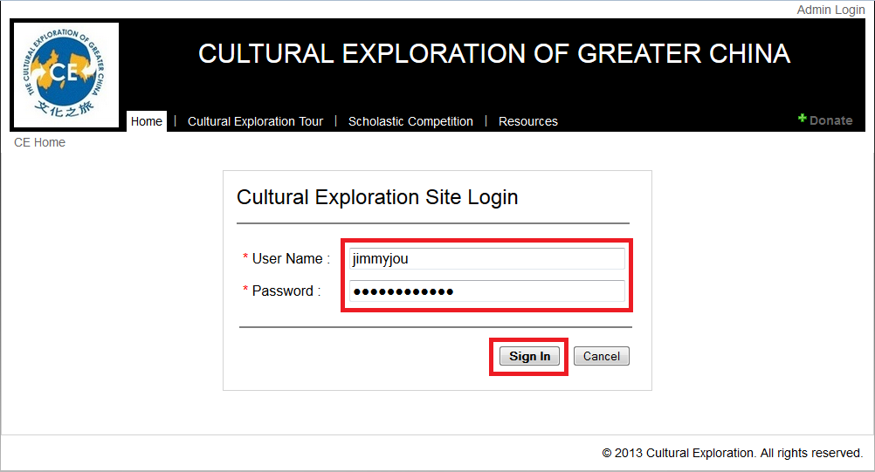

Once logged in, hover over the *Admin* menu and select *Review Applications* submenu.

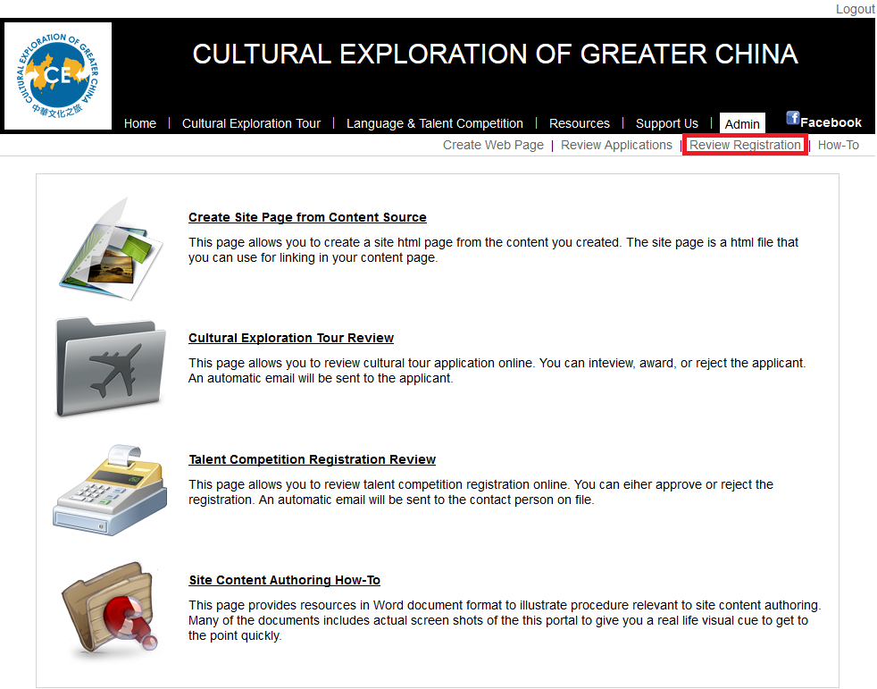

This submenu brings up the **online talent registration process page**.

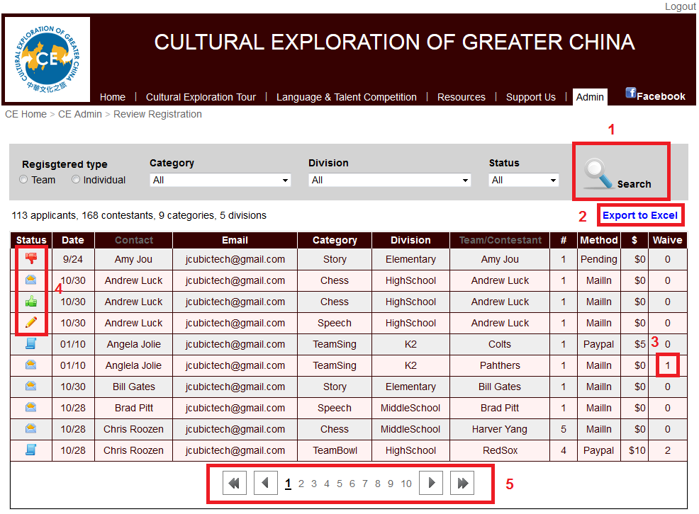

The **online talent registrationprocess page** provides functionality for processing online talent competition registration. The functionality includes the following features (red # refers to the screen shots below):

* Visual icon cue to indicate the status of each application (4)
  + The *paper* icon indicates that the applicant is applying for the competition.
  + The *mail* icon  indicates that the applicant is mail in a check for the competition.
  + The *thumbup* icon  indicates that the registration has been confirmed.
  + The *thumbdown* icon  indicates that the registration is cancelled.
  + The *pencil* icon  indicates that the registration is under review.
  + The *clock* icon  indicates that the registration is pending for Paypal payment verification.
* Search registration (1)

Search by competition category, competition division, and registration status.

* Export registration to Excel file (2)

The exported Excel file format matches those used in 2013.

* Application fee waiver (4) – number indicates the waived contestant count.
* Paging (5)

**View Talent Competition Registration Data**

Click the **status icon** of the applicant you want to view. A dialog screen will appear. Depending upon current status of the applicant, different content will be displayed in the dialog screen. The following are a few of the variations.

**Variation 1: Payment from Paypal that has been paid –**  Notice that fee waiver is taken into consideration.

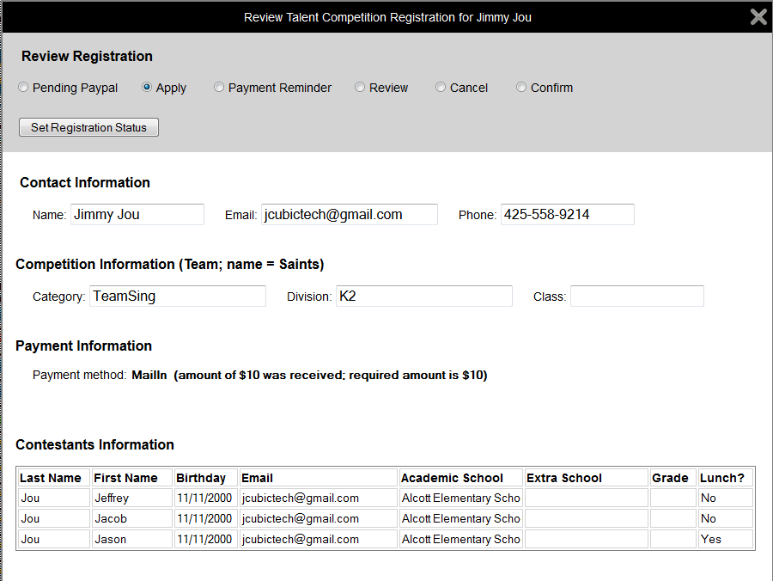

**Variation 2: Payment by Mail-in check that need veriication**

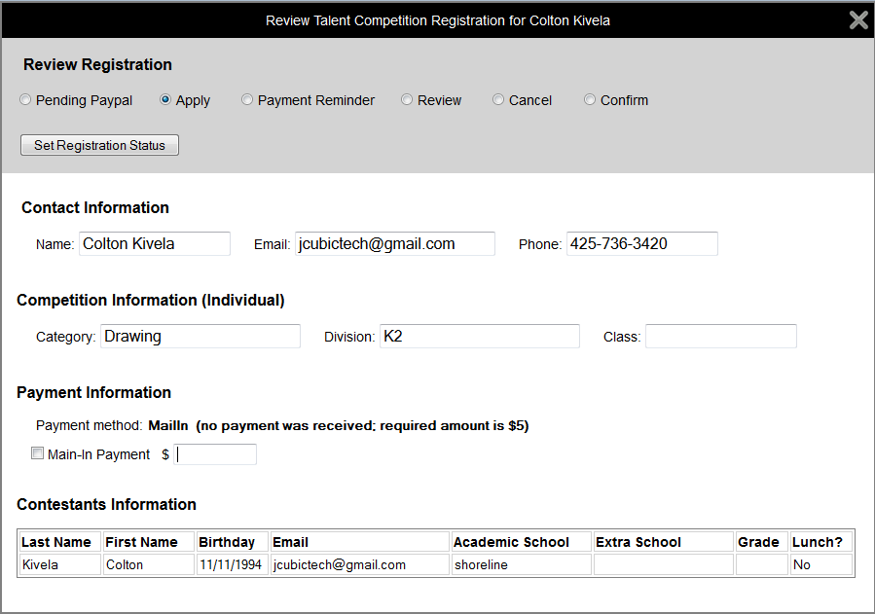

**Variation 3: Payment by Paypal that need verification –** Competition admin needs to go to CE Paypal account to check if the payment has been received.

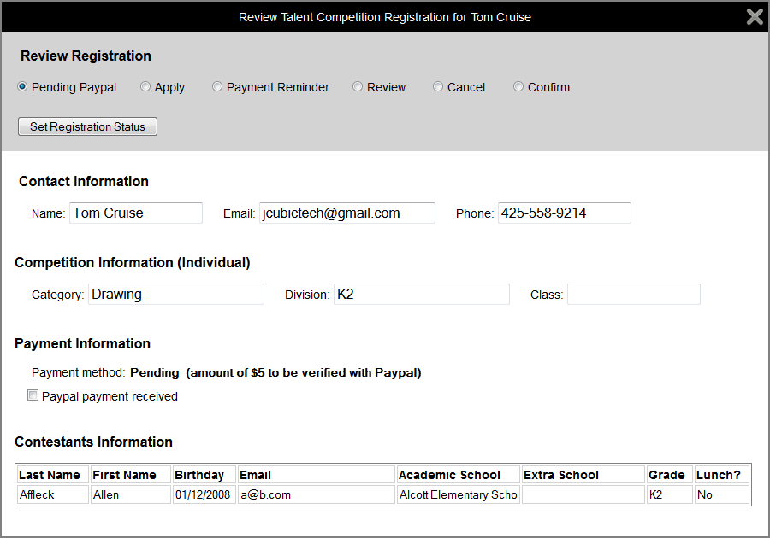

**Variation 4: Registration fee is waived –** This is the case that the contestant is in free lunch program.

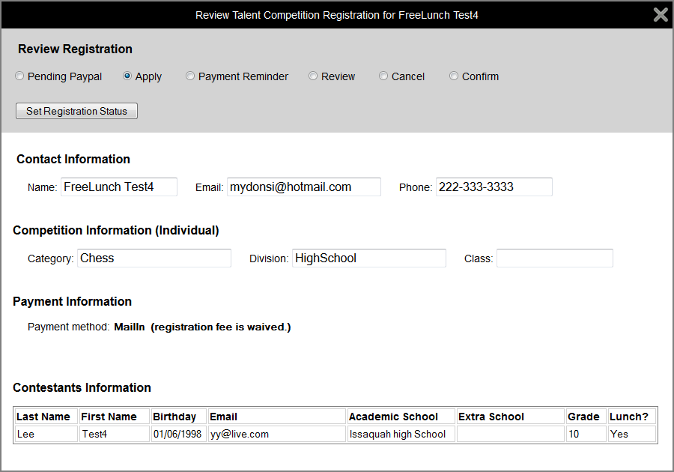

**Verification of Registration Fee**

For registration that needs fee verification either by Paypal payment or mail-in check, there is a checkbox in the dialog screen. The verification process is done manually.

The registration with status icon  indicates that it needs Paypal payment verification. CE Competition Team needs to go to CE Paypal account to check if the Paypal payment transaction has been coming through. If it is, check the *Paypal payment received* checkbox and click *Set Registration Status* button to complete the verification.

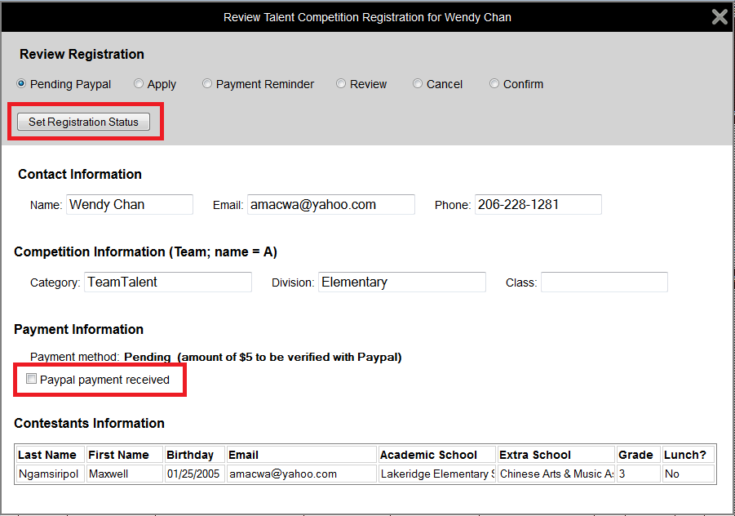

The registration with status icon  indicates that it needs mail-in payment verification. CE Competition Team needs to go to verify whether or not registration fee check has been received. If it is, check the *Mail-in payment* checkbox and enter the amount received. Click *Set Registration Status* button to complete the verification.

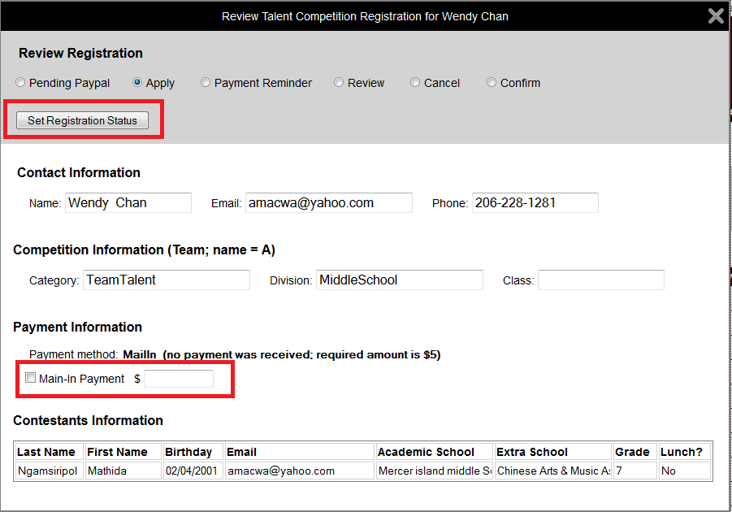

**Change Registration Status**

If the payment of a registration is verified or the fee is waived, the registration can then be confirmed by changing the status to *Confirm*. Conversely, if it is not, the status can be changed to *Payment Reminder* to give the registration contact another chance to pay the registration fee, or to *Cancel* to discard the registration.

